Programs day 2

1. WRITE A PYTHON PROGRAM TO FIND THE FACTORIAL OF GIVEN NUMBER?

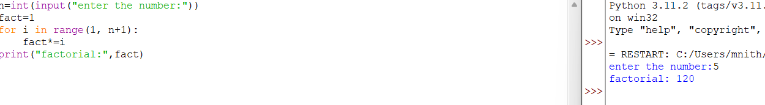

2.WRITE A PYTHON PROGRAM TO FIND SUM OF THE SERIES OF FACTORIAL? ( 1!+2!+3!+4!+ +n!)

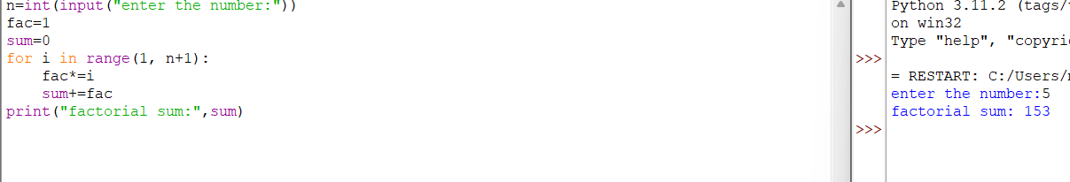

3.WRITE A PYTHON PROGRAM TO PRINT PATTERN?

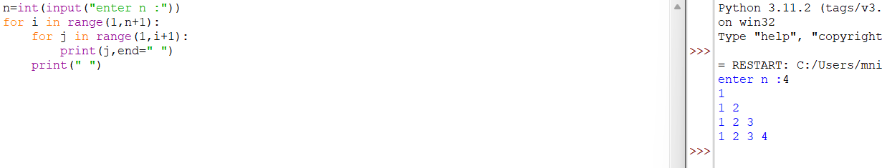

4.WRITE A PYTHON PROGRAM TO PRINT PATTERN?

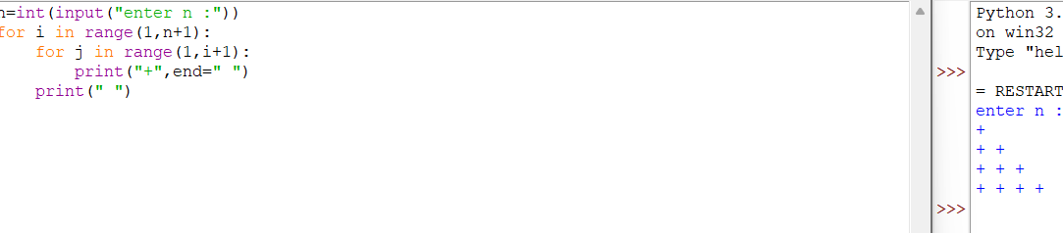

5.WRITE A PYTHON PROGRAM TO PRINT FIBONACCI SERIES OF GIVEN NUMBER?

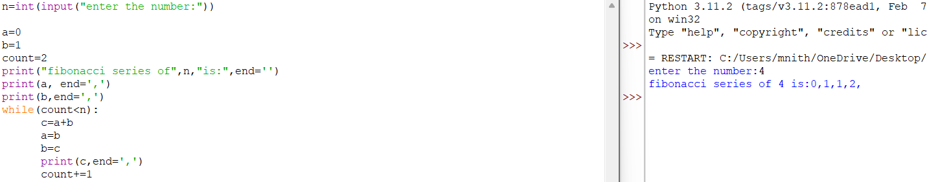

6.WRITE A PYTHON PROGRAM TO EXECUTE ADDITION OF TWO MATRIX?

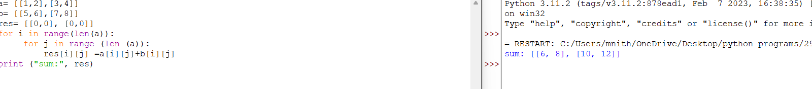7.WRITE A PYTHON PROGRAM TO EXECUTE MULTIPLICATION OF TWO MATRIX?

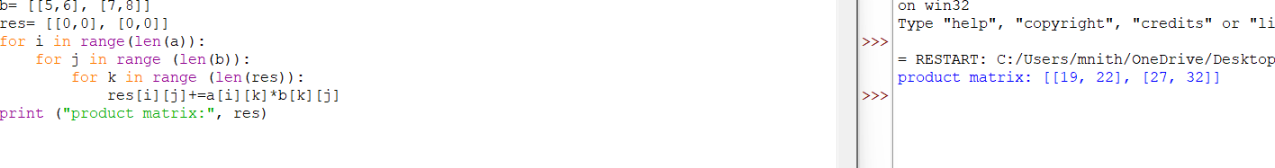8.WRITE A PYTHON PROGRAM TO EXECUTE TRANSPOSE OF A MATRIX?

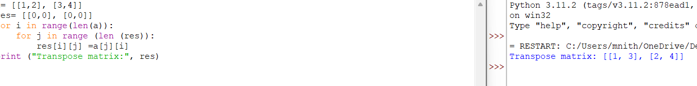9.WRITE A PYTHON PROGRAM TO SUM OF DIAGONAL,ROW AND COLUMN?

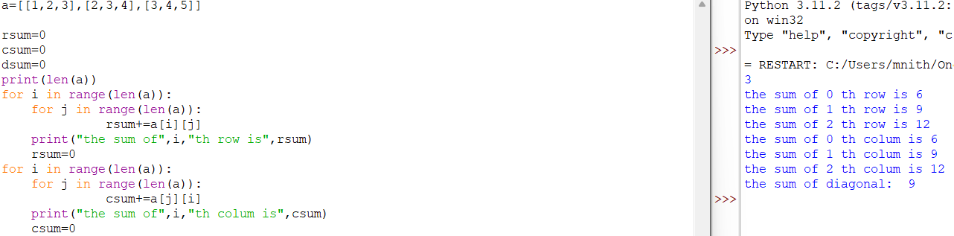10.WRITE A PYTHON PROGRAM TO PERFORM LIST OPERATIONS?

